**Washington and Wall Street: SEC’s Financial Reports from public companies**

Today’s post centers around the SEC’s EDGAR database, useful for compiling metrics and statistics of publicly traded companies that required by law to file their financial statements with the SEC quarterly.

The EDGAR database is an extremely useful one that anyone can access. Essentially, its most use friendly data comes in the form of .txt files, aggregating quarterly numbers from public companies. More detailed reports can be obtained by individually querying the website for the 10 k forms filed by companies.

A brief overview of financial statements is in order. I got my refresher from the SEC website itself. There are 4 sections to a financial statement:

(i) The balance sheet

(ii) Income statements

(iii) Operating expenses

(iv) Shareholder equity

**# Data Visualization, EDA:**

Of the 4 categories, I proceeded to select what looked like the explanatory variables with the most explaining power. I have listed there variables below:

# AccountsPayableCurrent - 1

# AccumulatedOtherComprehensiveIncomeLossNetOfTax - 2

# PropertyPlantAndEquipmentNet - 3

# CommonStockParOrStatedValuePerShare – 4

# AccountsPayableCurrent - 1

The Accounts payable metric is most clustered around 0, skewed to the right.

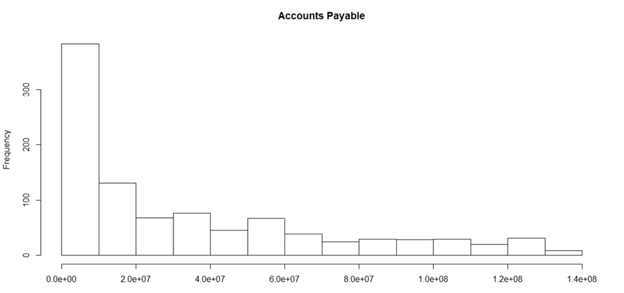

# AccumulatedOtherComprehensiveIncomeLossNetOfTax - 2

The “Accumulated Other Comprehensive Income Loss Net Of Tax” or what I am calling the bottom line, is skewed mostly to the left, mostly negative. Mind you, I have chosen to omit measures above the 75th percentile and below the 25th.

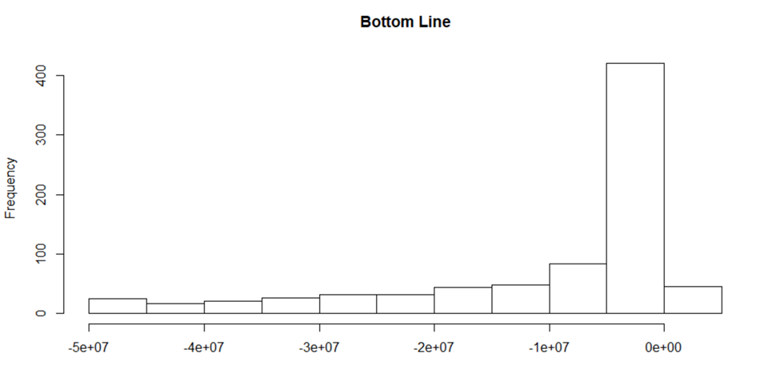

# PropertyPlantAndEquipmentNet - 3

PP & E, a clean measure of operating expenses, also all positive, is skewed right.

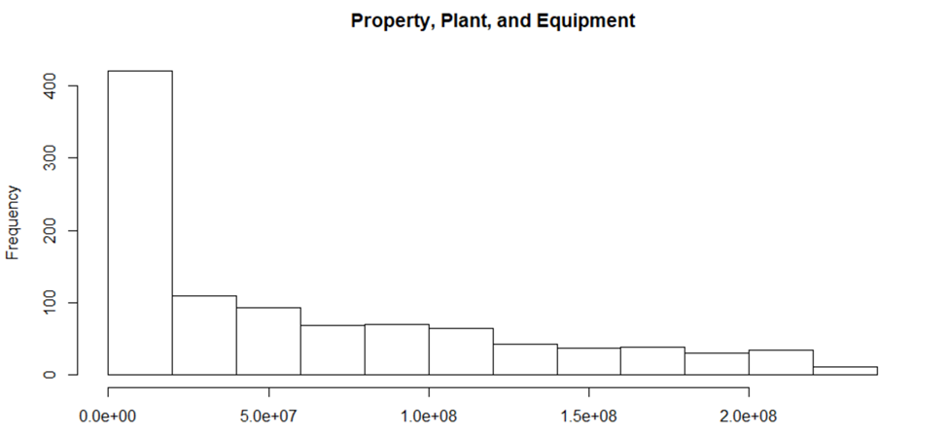

# CommonStockParOrStatedValuePerShare – 4

And shareholder equity, one of my favorite charts, indicates that most companies issuing public shares, are doing so at a price below .05, with a spike at around .01. The quintessential penny stocks, now make clear why the phrase arose in the first place.

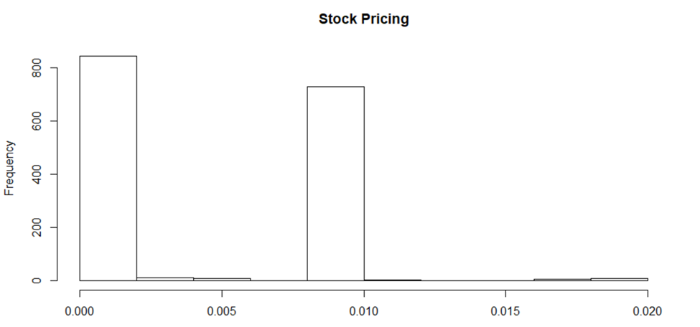

**# Regression Analysis: predicting the bottom line, by each section on the financial statement:**

(i) The balance sheet

The two predictor variables on this section on the balance sheet show up as significant predictors of the bottom line’s value, with accounts receivable the undisputed victor, based on the size of its effect. While the two are not exact inverses of one another, accounts payable, and accounts receivable do flow in opposite directions.

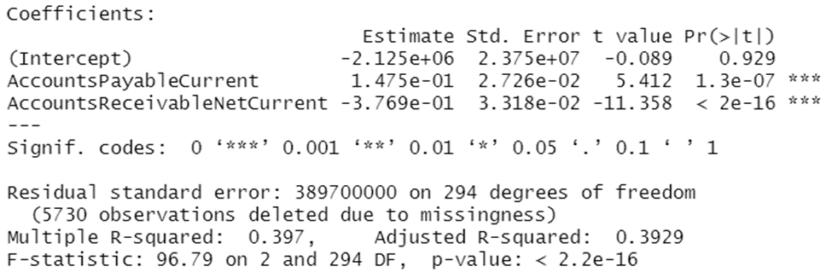

(ii) Income statements

Since the bottom line arises from the income statement, related metrics here are not the strongest predictors of the bottom line. In fact, as components of the bottom line calculation, they bear a very weak relation to the overall outcome of a companies net retained earnings post tax.

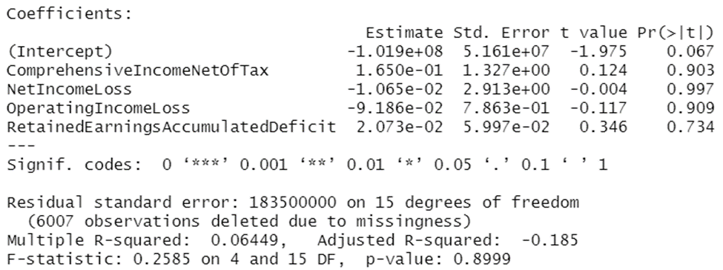

(iii) Operating expenses

The operating expense is an interesting one, and a section I’d expected to have greater explanatory power for the company bottom line. However, as more and more people are moving to remote work in the service industry, and labor intensive industries are slowly facing automation, this model explains a mere 30% of variation in the bottom line. Still, it is the depreciation, depletion, and amortization value that has the biggest effect on the bottom line. For companies that own their heavy machinery, this is bound to have an impact. For ones that simply rent their equipment, this expense is likely logged as a cash flow.

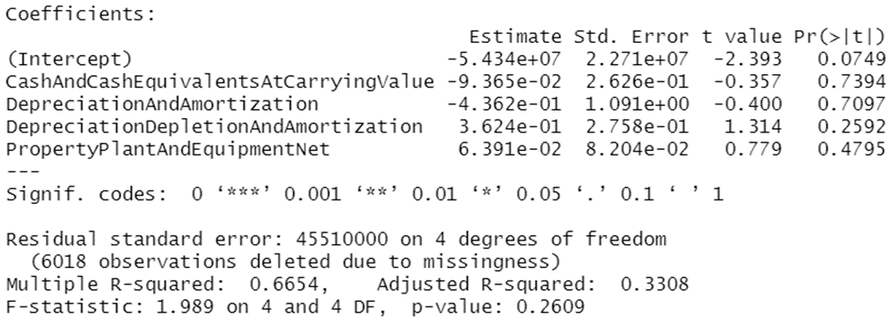

(iv) Shareholder equity

Lastly, and this is the most interesting to a layman, the effect of the shareholder equity section is encapsulated best in the number of common stock shares issued. The more the number of stock shares that are authorized, the lower is a company’s bottom line!

I have always wondered what effect going public has on a company’s profitability. Sure, issuing shares is a good form of raising capital. At the same time, it reorganizes the company structure, and reorders the decision makers to include majority shareholders, outside of the owners, and mangers of the company.

But to think that it would in fact decrease profit margins is to me altogether quite interesting, and a bit surprising. Something to note for company’s looking to go public in the future. This model also explains 55% of the variability in the bottom line, and is altogether more convincing than some of the other models run.

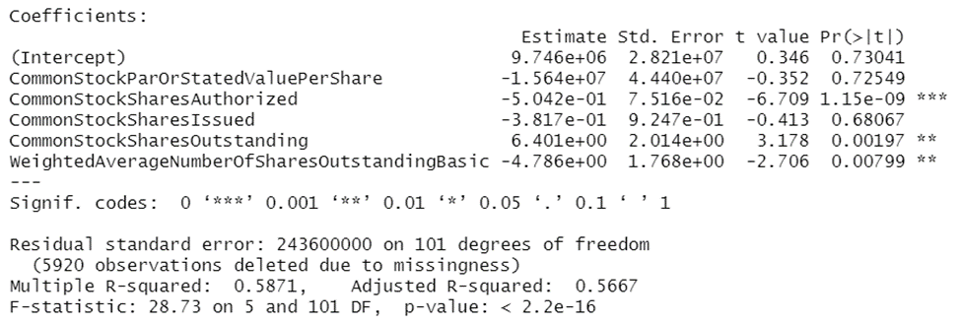

**# Final Financial Statements**

That concludes our discussion on financial statements, and the questions raised earlier in the discussion: what sections of the financial statements most affect a company’s bottom line?

That was answered both through our preliminary analyses, and drilling down, to be the shareholder equity section. Whether a company is privately held, or authorizes public shares, greatly impacts its profitability. But, it may also extend its sphere of influence, and grow the top line – which is a metric many forego, tend to oversee. So, before applying this lesson, we may want to ask ourselves – what are we optimizing for? The ends will determine the means. Profitability vs. size overall earnings, both serve different purposes, and are equally useful in different contexts.

Thank you for letting me take you through this.

I hope to field future requests!